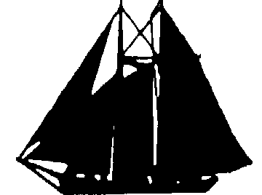

WEDLOCK & STONE
MARINE SURVEYORS
Capts. Stephen J Wedlock & Jeffrey R Stone; Ph: (415) 572-3281 e-mail: jrichmond7@juno.com

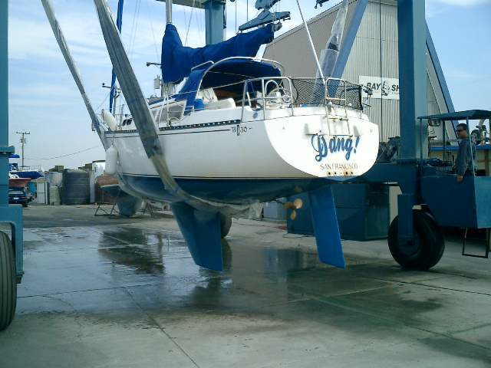
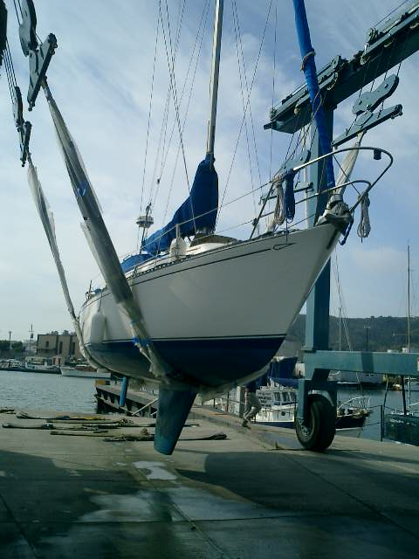

SURVEY REPORT #2587

By Request of: Sailor Sam
The main street.
San Francisco, CA.

Phone: (415) 123-456
Fax/E-mail: mickey@mouse.com

Date: October 3, 2003

Vessel Name: “Boris”
Type: Auxiliary Sail
Service Area: San Francisco Bay
Official #: 1065359
Certificate aboard / numbers attached: Yes/Yes
Hull ID #: XLY - B
Purpose of Survey: Condition and value for purchase & Insurance.
(Note: this survey is not to be used for transfer to a third party or use other than intended)

Where Surveyed: In water & drydock @ Bayship and Yacht, Richmond
Rig survey aloft
Attending: (Buyer)

Seller: Private Sale

Broker/Agent: 2Twin Rivers Marine Ins. Agency

7 Marina Plaza

Antioch, CA. 94509

Phone: (925) 777-2171
Fax/E mail: (925) 779-1749 / twnrvrs@pacbell.net

Estimated Fair Market Value: $ xx,000 Estimated Replacement Cost: $ 70,000
(As she lays) (New; similar construction)
1001 BRIDGEWAY PMB #490 SAUSALITO, CALIFORNIA 94965

Page 2 Survey #2587
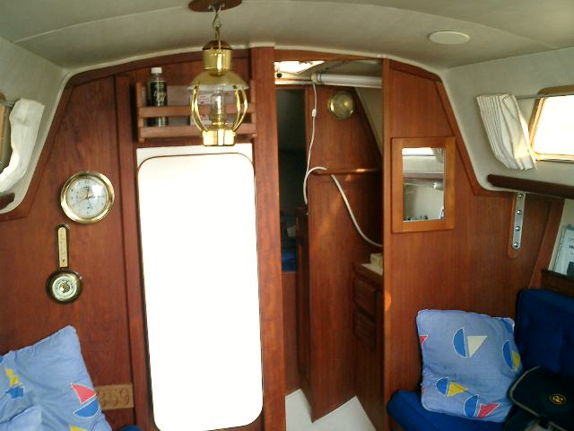

VESSEL PARTICULARS

Builder: Islander

Designer: Bob Finch
Year Built: 1981
Model: 30’ Islander Bahama
LOA: 29’ 11”
Beam: 10’ 00”
Draft: 5’ 00”
Displacement: 8,230 Lbs.
Ballast (type/amount): Lead / 3,130 Lbs.
Hull Type: Fin keel / spade rudder
Material/Color: Fiberglass / white

HULL AND SUPERSTRUCTURE:

Deck: Non-skid fiberglass
Cabin Sole: Carpet over FRP; Plywood bilge access panels

Bulkheads: Teak veneer plywood

Hatches&Ports-Gaskets: Appear good (Note)
Construction Scantlings: Single skin gel coat over multiple layers of resin impregnated fiberglass.
Superstructure/Layout: Low trunk forward to aft cockpit / chain locker way forward then vee berths followed by port head w/ stbd vanity. Saloon is next aft w/ port and stbd settees, port side fold up dining table. Galley is aft to port, nav station is aft to stbd w/ quarter berth behind.
General Condition: Structure appears sound. Vessel is very clean and appears to have been maintained to high standards under the past owner.

PROPULSION SYSTEM

General Condition: Space is clean, equipment appear well maintained - operational
Type: Diesel
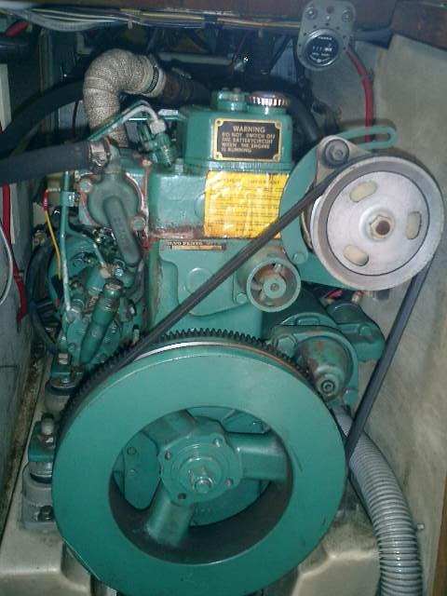
Hours: 707 “By meter”
Manufacturer: “Volvo Penta”
Model: MD 7A
Serial Number: 32347
#Cylinders/HP: 2 / 13
Year/Year rebuilt: Assumed Original
Cooling System: Raw water
Alarms: Yes
Gauges: Full @ helm
Exhaust(s): Reinforced hose
Silencer(s): Steel Can type
Reduction Gear: Yes; Ratio 1.91:1
Belts/Hoses: Appear good
Shaft: 3/4“ Stainless Steel
Stuffing Box: Traditional (Note)

Page 3 Survey #2587

Strut/Bearing: Single leg Bronze / Cutlass – good
Propeller: 3 bladed Bronze 14LH10 – Spare 2 Blade Bronze 12LH14 aboard
Controls: Dual Single lever – operate smoothly
Eng. Beds/Mounts: HD stringers / Appear new - good

MECHANICAL SYSTEMS

General Condition: Good – well maintained – equipment operational and clean
Eng.Rm.Ventilation: Natural
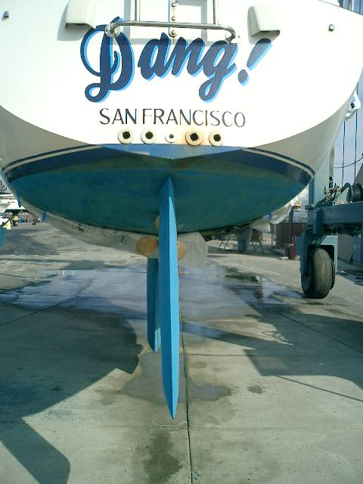
Insulation: None
Wheel/Tiller: SS wheel – “Edson”
Steering Gear: Cable to quadrant – cables in good condition – sheaves well mounted bearings tight
Emergency Steering: Tiller
Rudder: Foam filled FRP – minor separation noted stbd fwd side of rudder (Note)
Rudder Post Gland: Tube and bearing – bearings have only slight wear. Rudder appears canted to stbd slightly (Note)
Bilge Pump(s)-Manual: Diaphragm in cockpit
Auto: “Rule” 2000 Gph
Potable Water-Manual: Foot pump
Pressure: “Shur-Flo” w/out accumulator
Air conditioning/Heating: None
Head(s): “Groco” manual
Holding Tank: Plastic – 20 Gals
Macerator: None – diaphragm hand pump waste discharge. Head discharges direct to holding tank
USCG Approved: Yes w/ “Y” valve (33 USC 159)
Showers: Handheld in head
Sump/Pump: Drains to bilge
Anchor Windlass: None
Zincs: Replaced at haul out

ELECTRICAL SYSTEMS

General Condition: Good – AC systems not tested (Battery charger, water heater)
DC-Batteries/Amps: (2) 12v Gp27 - New
Boxes: Plastic w/tops straps
Approved: Yes (ABYC E 10.7.1 – 10.7.12)
Battery fluid level: Sealed type
Condition of terminals: Good
Engine Alternator/Amps: Est. 55 amps
Charger/Amps: “Professional Mariner” / 20 amp
Vapor Proof Switch(es): “Guest”
Panel Location: At nav station
Circuit Protection: Magnetic breakers & Fuses
Wiring: Stranded copper
Installation: Well loomed
Page 4 Survey #2587

AC-Shorepower: 30 amp cable
Cabin Lights: 12v - good
Spreader Lights: 12v - good
Navigation Lights: 12v – good – steaming light is out (Note)
Anchor Light: 12v - good
Hot Water Heater: “Seaward” 6 Gallon - 120vac
Bonding system / Condition: None

GALLEY EQUIPMENT

General Condition: Good – equipment is well laid out and appears thoughtfully maintained
Sink(s): Stainless Steel
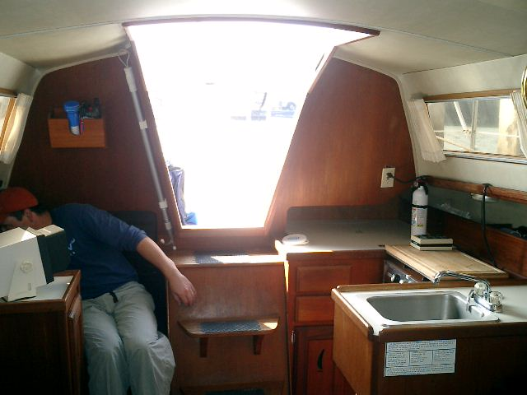
Refrigeration: Icebox
Stove Type: “Gas Systems” CNG
# Burners/Oven: Two w/ oven
Tank Stowage: After cockpit locker (Note)
Safety Solenoid: No - w/ gauge (Note)

TANKAGE AND PLUMBING

General Condition: Spaces and equipment clean - good
# Fuel Tanks/Capacity: One / 20 Gals
Material: Aluminum
How Secured: SS strapping – under cockpit sole
Accessibility/Condition: Ltd / appears good
Fills/Vents/Overflows: On deck / topside
Bonding (Fill to Tank): Yes (ABYC H 24.15.1)
Fuel Lines/Clamps: Neoprene - approved
Filters: “Racor” and secondary
Valves/Manifold: At tank
# Water Tanks/Capacity: One / 40 Gals
Material: Plastic
How Secured: Framing – stbd settee
Accessibility/Condition: Ltd / appears good
Fills and Vents: On deck
Hoses/Clamps: Good
Filters: In line at pump
Valves/Manifold: None observed
Thru-Hull Fittings/Valves: Bronze and Marelon ball valves – valves appear to have been recently replaced
Approved: Yes (ABYC H – 27.4, 27.5)
Condition: Working
Clamps/Hoses: Double / reinforced
Anti-Siphon Loops: Yes
Raw water Strainers: Bronze
Hose Chafing?: None Observed

Page 5 Survey #2587

ELECTRONICS/NAVIGATION EQUIPMENT

General Condition: Good – equipment operational except as noted
Compass(es): “Danforth” 4 inch in pedestal
VHF Radio: “Horizon”, new “Standard” w/ DSC (not yet installed) and Hand held
Speed Log: “Datamarine” – power to unit, does not register speed – impeller in backwards (Note)
Wind Indicator: “Windex”
Depthfinder: “Datamarine”
GPS/Loran: None observed
Radar: “Furuno 1720”
Barometer: Yes
Ship’s Clock: 6 inch Brass

DECK EQUIPMENT

General Condition: Good – covers appear new, ground tackle adequate to vessel and service
Anchor(s): CQR 20 Lb. primary; 13Lb Danforth secondary
Chain/Rode(s): 5/16” x 20’ / 1/2” x 200’ Primary – 1/4” x 20’ / 1/2” x 200’ secondary
Bow Roller(s): On stem
Bow/Stern Pulpit: 1” Stainless Steel / 1” SS
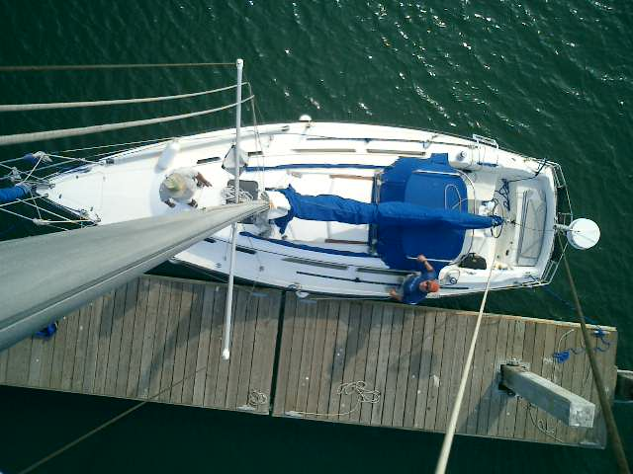
Stanchions/Lifelines: 1” SS / double wire
Docklines: Misc. braid
Fenders: Medium pneumatic
Covers: Dodger, mainsail full covers below – appear new, not inspected
Swim Ladder: SS

SPARS, RIGGING AND SAILS

General Condition: Spar was inspected aloft. Welds appeared in good condition. Shroud terminals appeared in good condition. All swages appeared good. Gooseneck, boom end, all sheaves and halyards, bails and hardware attachments, were inspected and found in good condition.
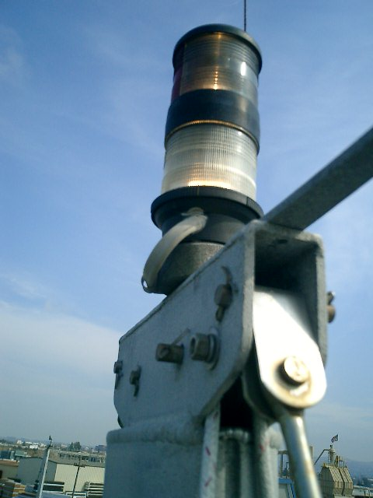
Type of Rig/# Masts: Sloop / One
Material: Aluminum
Where Stepped: On deck
Condition of Step: Good – teak compression post below was in good condition, no cracks or deterioration was noted.
Keel bolts: Ballast is encapsulated
Standing Rigging: 1x19 SS wire
Condition: Appears good aloft and alow
Terminals: Swaged
Turnbuckles/(pins?): SS Bronze / yes no
Chainplates/Stem: SS – bulkheads were found sound and secure w/ no apparent leaks through bedding
Page 6 Survey #2587

Spinnaker Pole/Reaching Strut: Aluminum
Running Rigging: Dacron braid
Condition: Good
Winches: “Lewmar” 2x#8, 1x#30ST, 2x #405
Rigging details (vang/traveler,etc.): “Harken” hardware on deck, “Hood” roller furler, Halyards lead aft, rope vang.
Sail inventory: Main, roller furling jib, one bag below – Not inspected

SAFETY/REQUIRED EQUIPMENT

General Condition: Good; except as noted
Throwable Device: Horseshoe & Lifesling
PFD’s: USCG Type II (33 USC 175)
VDS: “Olin” kit (33 USC 175) expired (Note)
Horn/Bell: Handheld freon / NA
Radar Reflector: Yes
Oil/Pollution Placards: Yes / Yes (33CFR151.9)
Fire Extinguishers: (3) 3# ABC dry chemical
Condition: Gauges in green
Fixed Fire System: “Fireboy” Halon FE241 (Suggested)
CO detector/ Gas sniffer: “Suggested” / “Suggested”

REMARKS AND RECOMMENDATIONS

This Islander 30 was found in above average condition. Bilge and all spaces were found cleans and dry. Equipment where tested was found operational, thoughtfully installed, and well maintained.
The rig, inspected aloft was found in good condition. All running gear, standing rig, and etc. were found in good condition.
The hull and deck were found clean and well maintained with no apparent separation, or delamination. Light non structural osmotic blistering was noted on the bottom. The rudder was noted to have a slight stbd skew.
In as far as may be ascertained from a general inspection, without making extensive removals or opening up to expose ordinarily concealed areas, and without taking borings to determine thickness or soundness of structures and members, or testing for tightness of components. Upon compliance with the following required items, this vessel should represent a sound financial and insurance risk.

Note: The N.F.P.A. National Fire Protection Association, and ABYC (American Boat and Yacht Council), do not represent legal requirements, only safety standards. Non -conformity can affect insurance. U.S.C.G Requirements are law by the Federal Boat Safety Act of 1971.

REQUIRED NOW

- Assure a minimum of (3) visual distress signals are aboard that have future expiration dates. (consider SOLAS standard) (46CFR28.145)

- Assure steaming light is operational.

Page 7 Survey#2587

AT OWNER’S DISCRETION / IN NEAR FUTURE:

- Suggest regular pressure hose test to all ports and hatches to check watertight integrity and examine rubber gasketing for cracking.

- Shaft and rudder stuffing glands, thru-hull valves and zincs should be serviced as necessary at each haulout.

- Suggest installation of vent in cockpit coaming above CNG.

- Suggest installation of 12v remote activated shut off solenoid.

- Repair/replace speed impeller (impeller is, at present, installed facing aft.

- Replace cracked bilge Pump discharge thru hull flange (at next scheduled haulout). Note that fitting is above LWL.

- Epoxy injection into rudder at separation noted at survey may be undertaken at the next haul out.

SURVEY LIMITATIONS and SCOPE:

1. Parts of most vessels cannot be examined due to inaccessibility, Some removal procedures add greatly to the time involved and, consequently to the cost. Therefore such procedures are not performed unless specifically requested or recommended. Engine surveys and oil analysis are separate surveys and are recommended. Surveyors do not: Test the vessel, hull or tanks for tightness or leaks; 2: Unload cluttered holds or lockers; clean bottoms; operate the vessel. It is pointed out that where wood decay is involved, it is not unusual for repairs to uncover previously hidden additional decay.

2. We recommend surveyor attendance underway to test gear under working conditions. The vessel was examined in the water and / or drydock (see page one for details). The hull, deck, and house were sounded for structural integrity. Sole boards were lifted and accessible drawers and lockers were opened for inspection. Machinery, electrical and electronic equipment were operated except as noted.
- Attendance underway: ____JRS_____Declined ________Accepted

3. The report is confined to the surveyor's opinion as to the general physical condition and estimated value of the vessel. It does not include a determination as to the seaworthiness of the vessel, nor does it include stability tests necessary to determine such limitations, nor does it attempt to itemize waters unsuitable for the vessel's use.

Signed without prejudice,

Jeffrey R. Stone: Society of Accredited Marine Surveyors (SA; Y, SC)
Master, 1600 Gt. Oceans

Member ABYC

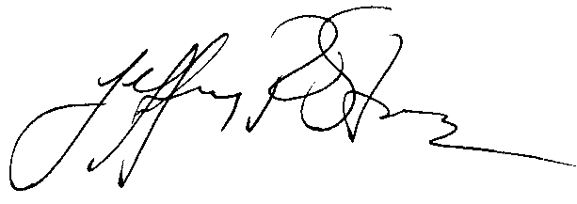 (415) 572-3281

STATEMENT

CONDITION AND VALUATION SURVEY

30 ’ x $12/ft $360 .00
Rig survey aloft $100.00
Paid to Jeffrey R. Stone -- $460.00

With thanks and fair winds,
Capt. Jeffrey R. Stone

Jeffrey R. Stone @ 1001 Bridgeway # 490, Sausalito, CA 94965

